**Hackerrank**

You are given a table, *BST*, containing two columns: *N*and *P,* where *N* represents the value of a node in *Binary Tree*, and *P* is the parent of *N*.

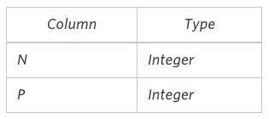

Write a query to find the node type of *Binary Tree* ordered by the value of the node. Output one of the following for each node:

* *Root*: If node is root node.
* *Leaf*: If node is leaf node.
* *Inner*: If node is neither root nor leaf node.

**Sample Input**

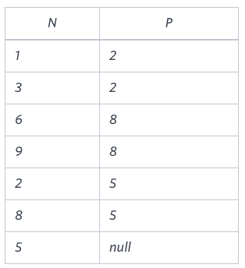

**Sample Output**

1 Leaf

2 Inner

3 Leaf

5 Root

6 Leaf

8 Inner

9 Leaf

**Explanation**

The *Binary Tree* below illustrates the sample:

